# **Practical 05**

AIM : Installation and Configuration of virtualization using KVM.

**Software Tools Required**

* **Virtual Machine Monitor:** VMware Workstation
* **Operating System:** Linux

**Downloads Required:**

* Virtual Machine Monitor**:** [Download VMware Workstation Pro 17.6.0 Build 24238078 for Windows | Uptodown.com](https://vmware-player.en.uptodown.com/windows/download)
* Operating System:[Download Ubuntu Desktop | Ubuntu](https://ubuntu.com/download/desktop?form=MG0AV3) (for Linux distribution of your choice)

Open Vmware Workstation and start the steps

**Demonstration:**

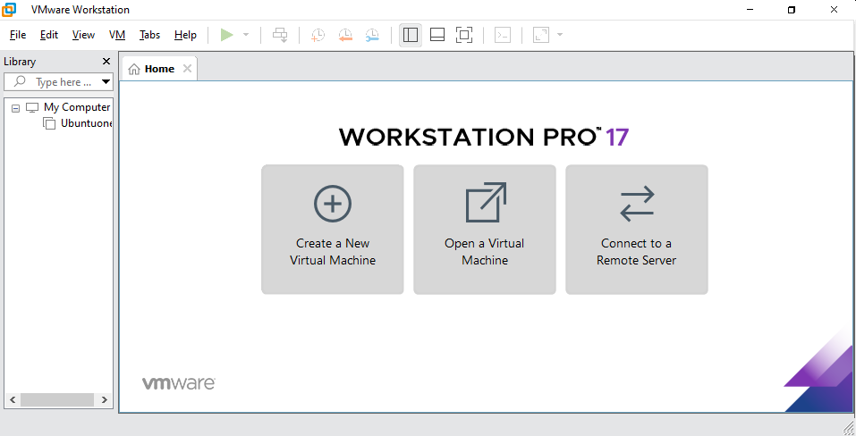

Create a New Virtual Machine >

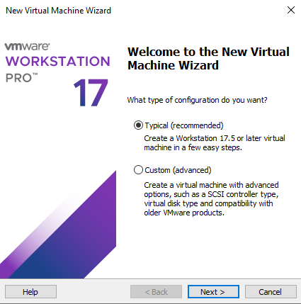

Browse and place the ISO File

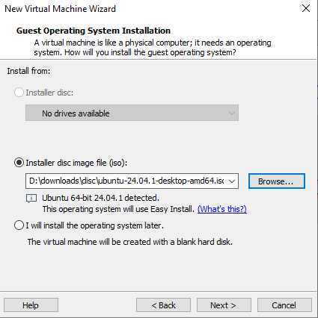

Provide full name as **Practical5** and user name as **example** and password and confirm password as **linux**

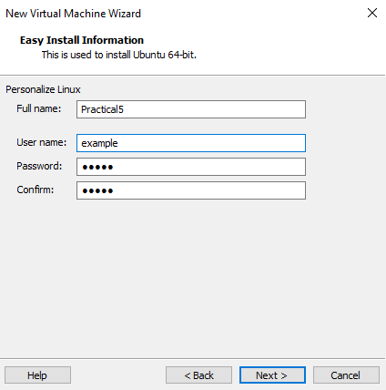

Give virtual machine name as **KVM**

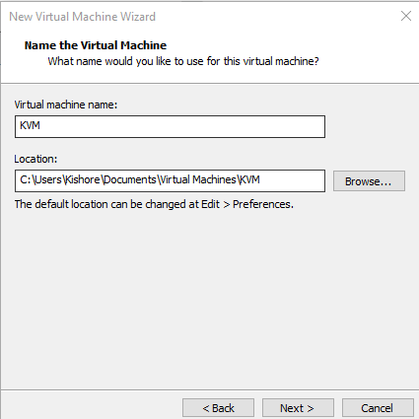

Provide disk size: 16.0GB then click Next

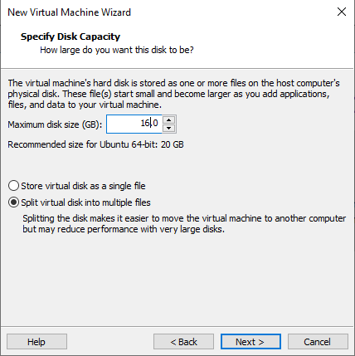

Click on Customize Hardware

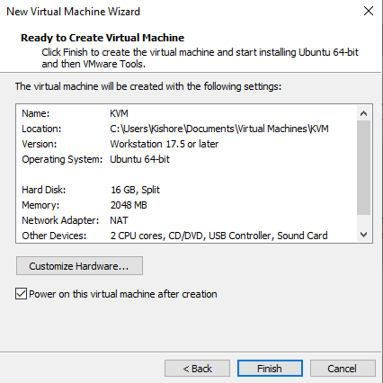

To enable KVM

Check the Virtualize Intel VT

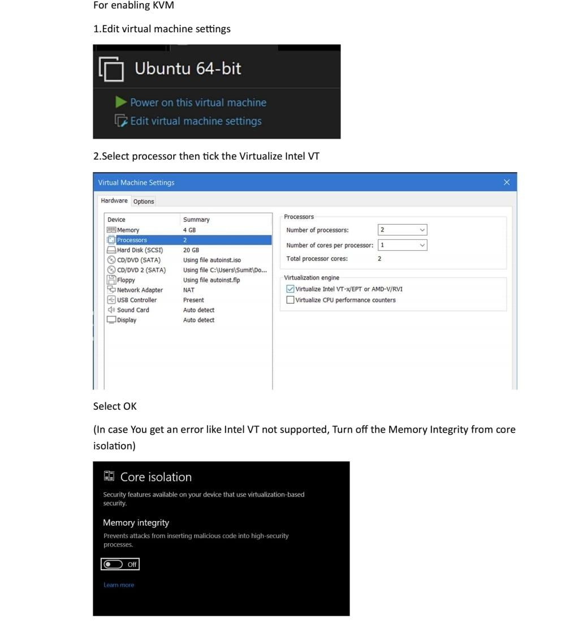

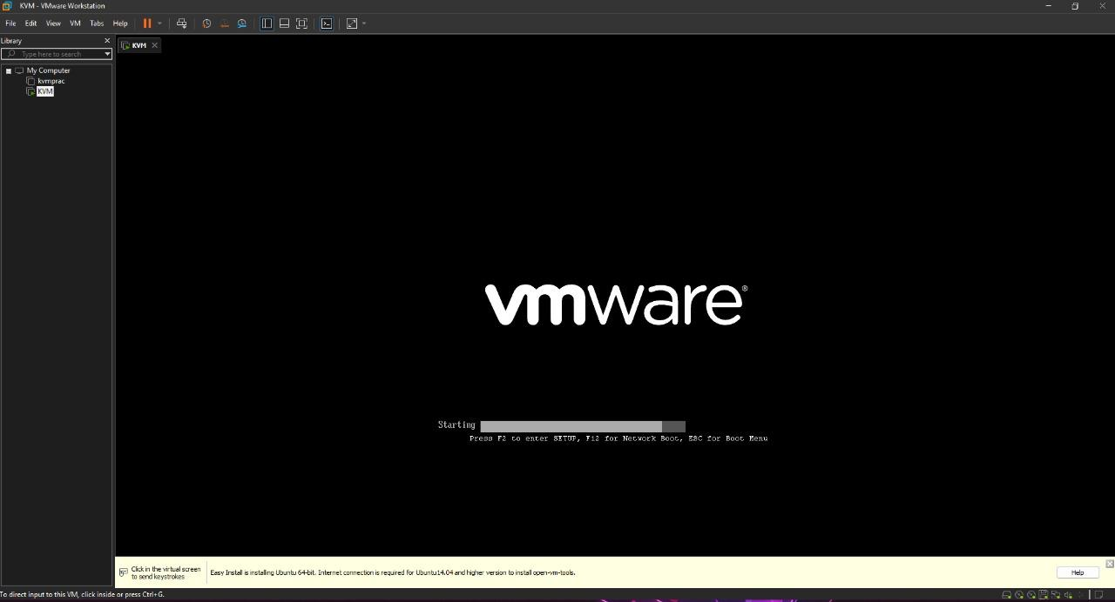

Ubuntu, a linux Distribution system will load.

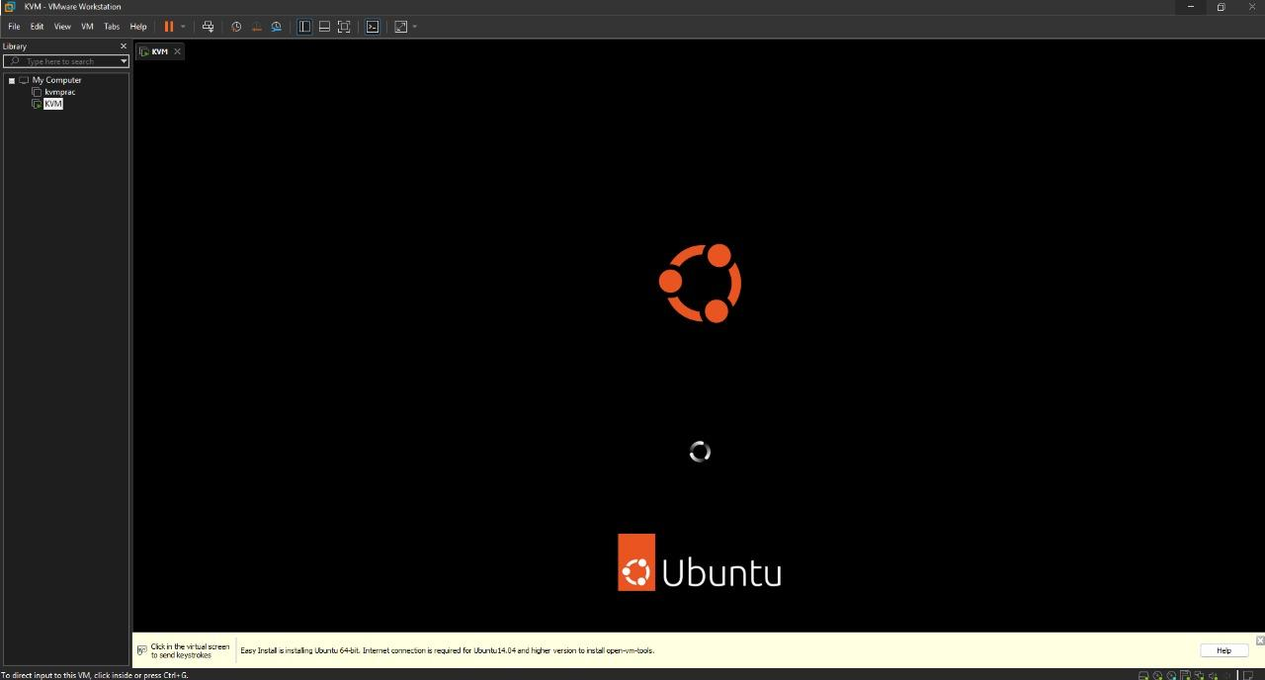

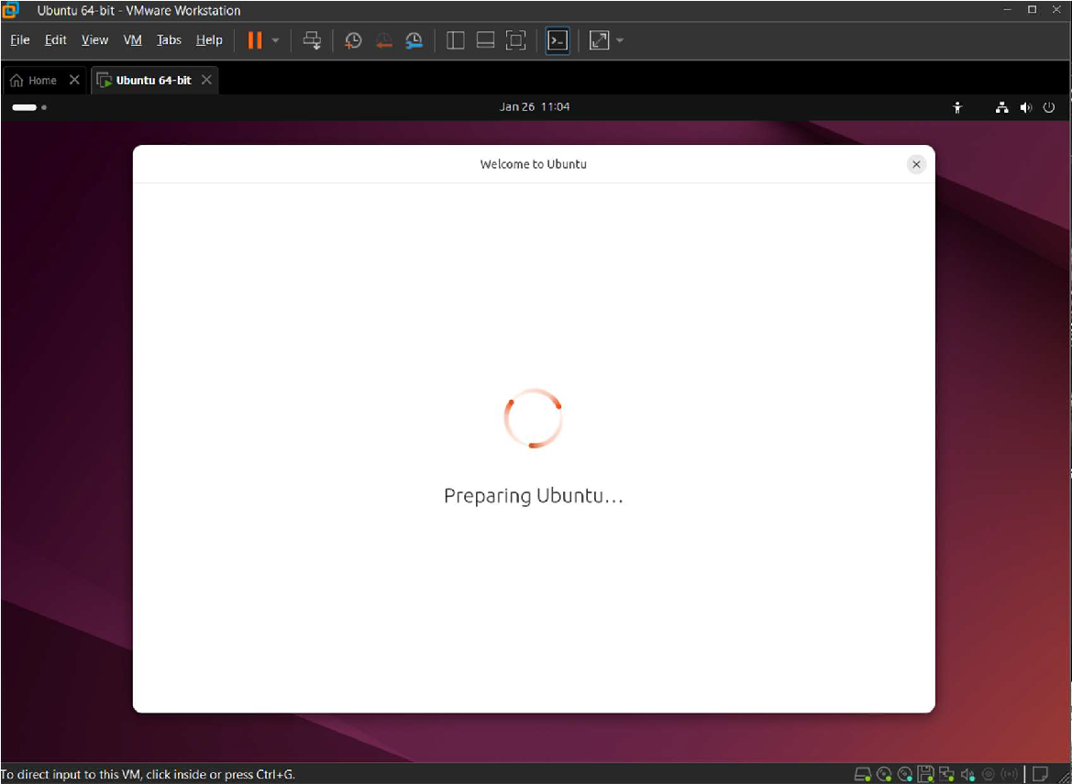

**Ubuntu Setup:**

1.Choose Language then click next

2.Then in Accessibility Tab Click next

3.Keyboard Layout As English US then next

4.Connect to Internet then next

5.Tick Install ubuntu then next

6.Interactive then Default Installation

7.Install Proprietary Software (tick both options)

8.Then Tick Erase disk and install ubuntu

9.Then Fill up the following details:

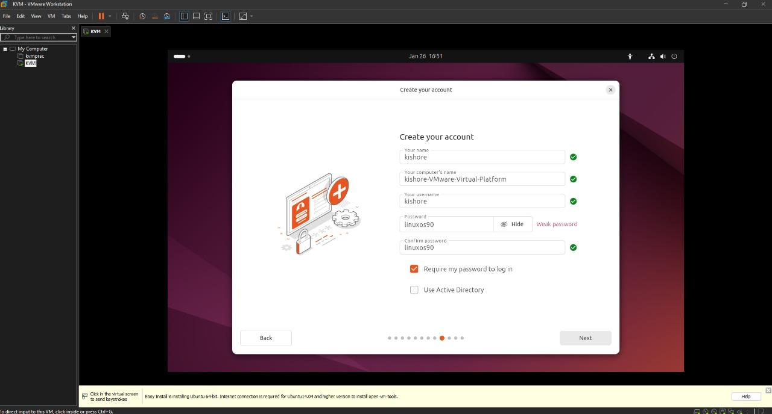

10.Then set the time zone and click next

Location: Mumbai

Timezone:Asia/Kolkata

11.Then Following window appears, Click Install

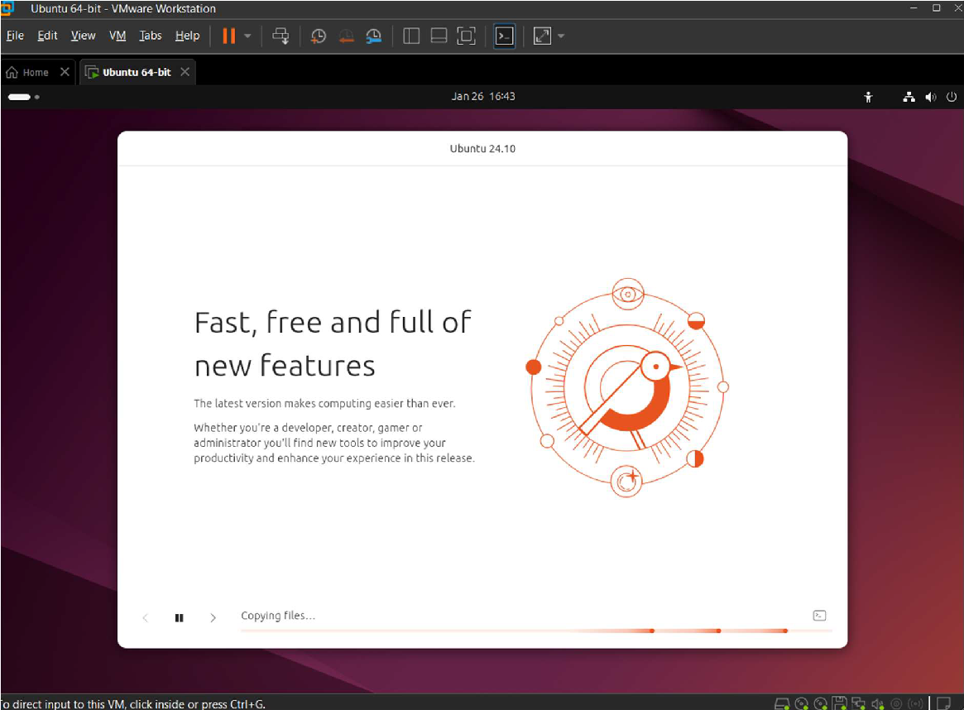

We get the following screen,

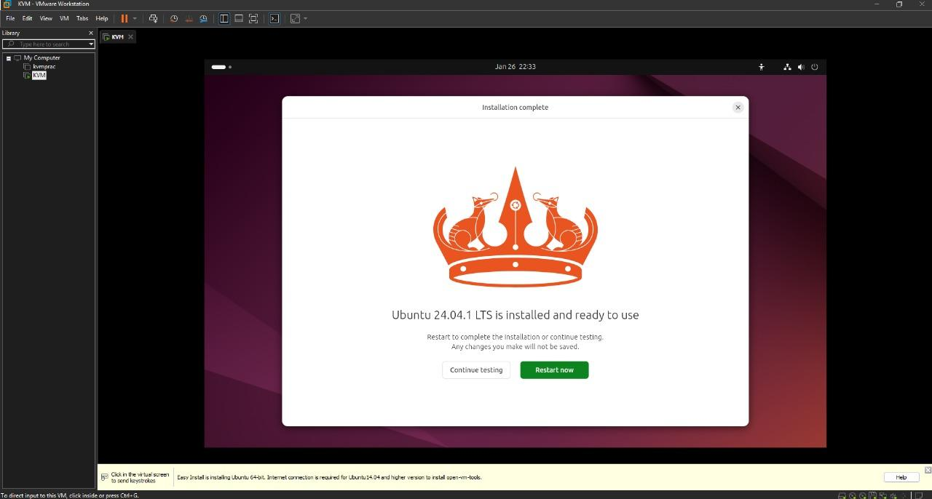

Click Restart.

Now login using your password.

1. KVM Setup Steps: Open Terminal

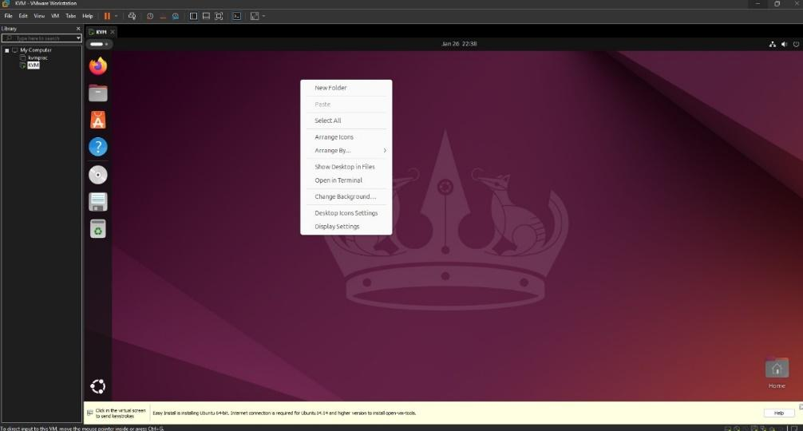

* 1. Update the System

**sudo apt update && sudo apt upgrade -y**

* 1. Check if Virtualization is Enabled:

**sudo grep -c "svm\|vmx" /proc/cpuinfo**

* 1. Verify KVM Virtualization

Check if KVM virtualization is enabled by running command:

**kvm-ok**

If the kvm-ok command is not found, install the CPU checker tool: **sudo apt install cpu-checker**

**then type kvm-ok**

**Output should include:**

**INFO: /dev/kvm exists**

**KVM acceleration can be used.**

* 1. Install KVM and Required Packages

**sudo apt install qemu-kvm virt-manager libvirt-daemon-system libvirt-clients bridge-utils -y**

* 1. Enable the Virtualization Daemon Start and enable the libvirt daemon:

**sudo systemctl enable libvirtd**

**sudo systemctl start libvirtd**

* 1. Check the Status of the Libvirt Daemon

**Verify that the daemon is running:**

**sudo systemctl status libvirtd**

* 1. Add Your User to KVM and Libvirt Groups

Replace your-username with your actual username and run the following commands:

**sudo usermod -aG kvm your-username**

**sudo usermod -aG libvirt your-username**

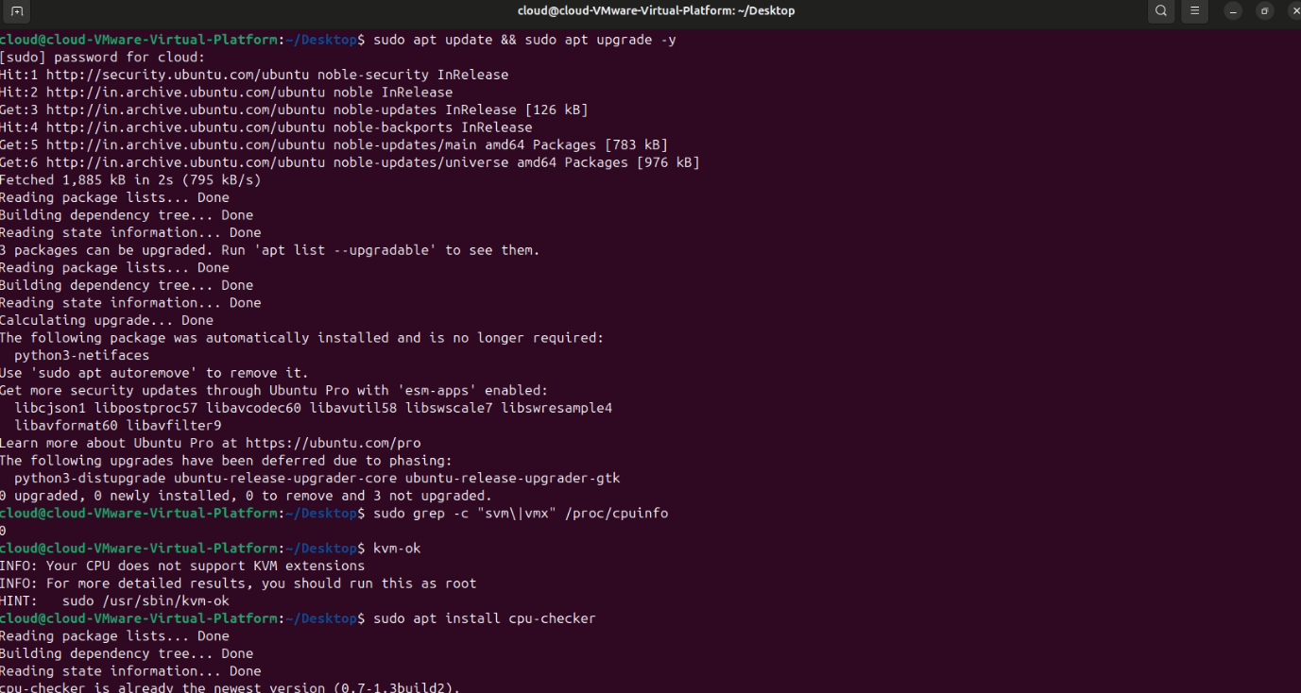

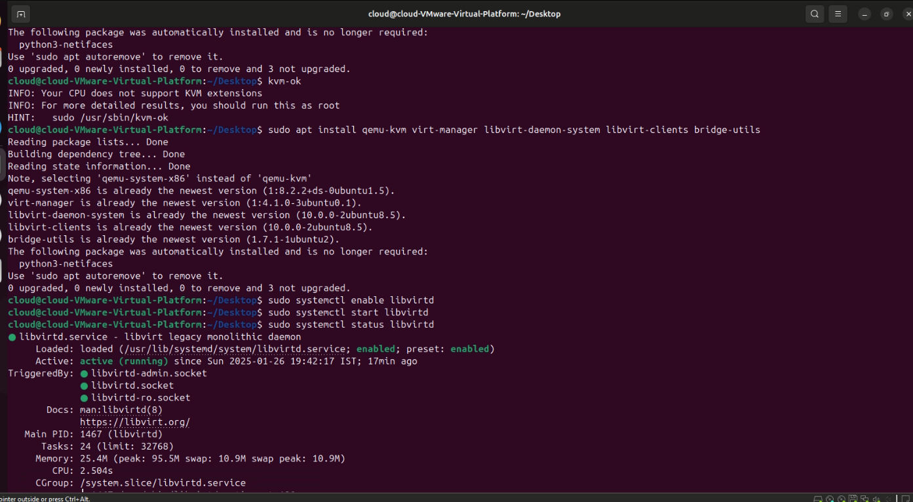



* 1. Log Out and Re-login

Log out from your system and log back in to apply group changes.

* 1. Run KVM Virtual Machine Manager

Search for "Virtual Machine Manager" in your system applications and launch it.

* 1. Prepare to Create Virtual Machines

In Virtual Machine Manager, click Create a New Virtual Machine to begin setting up virtual environments.

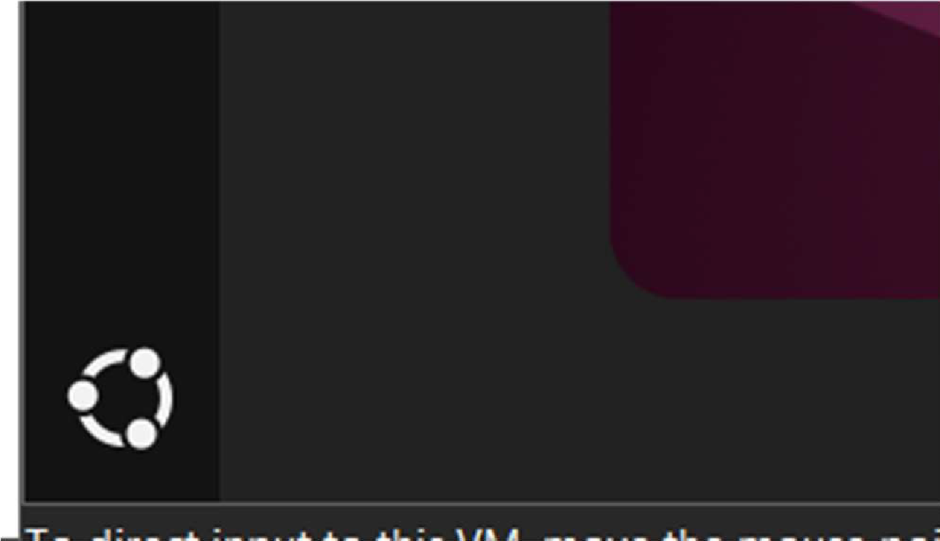

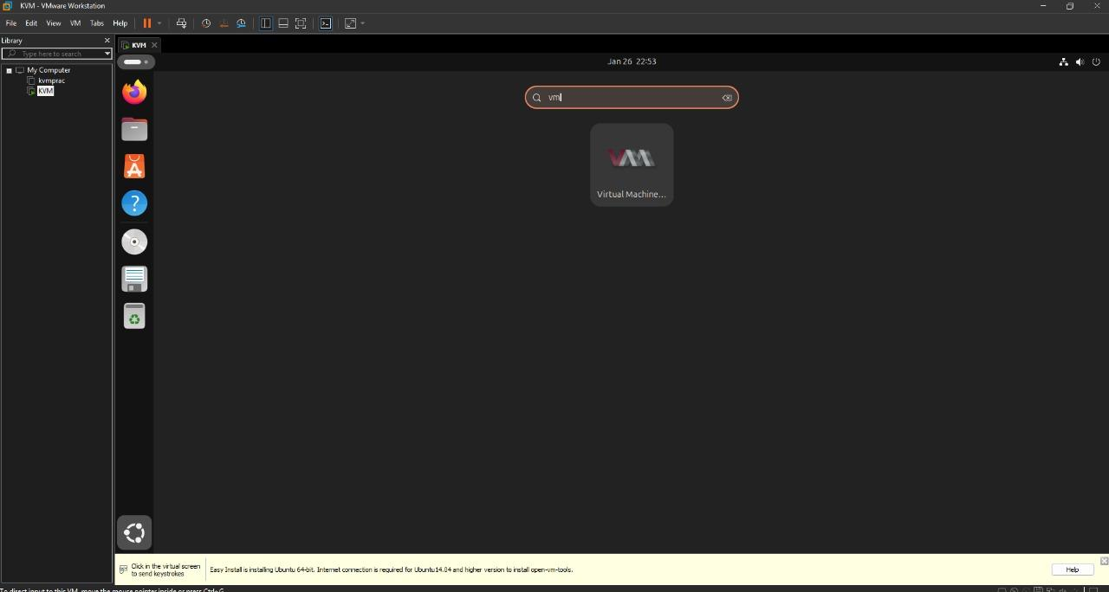

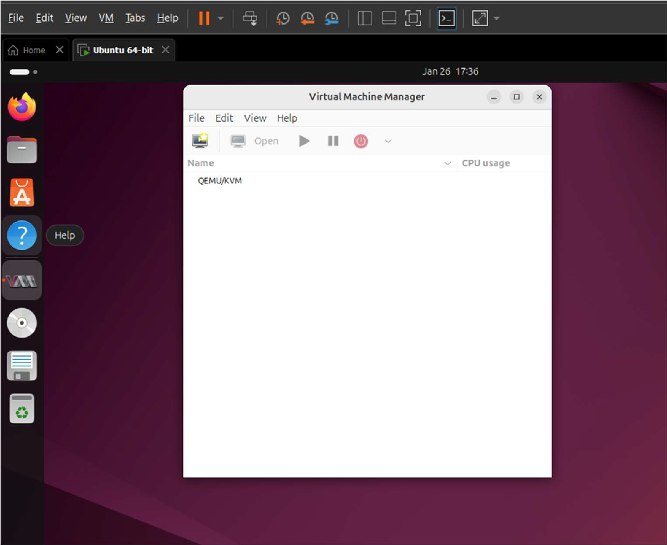

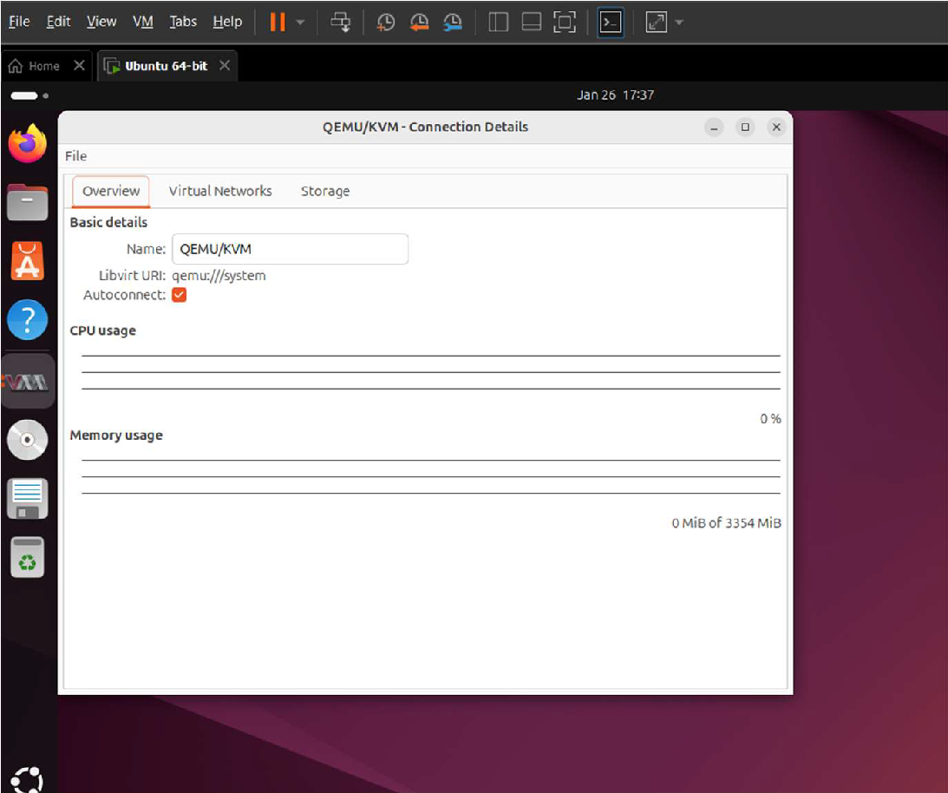

Now we can create new virtual machine from File>Create New Virtual Machine

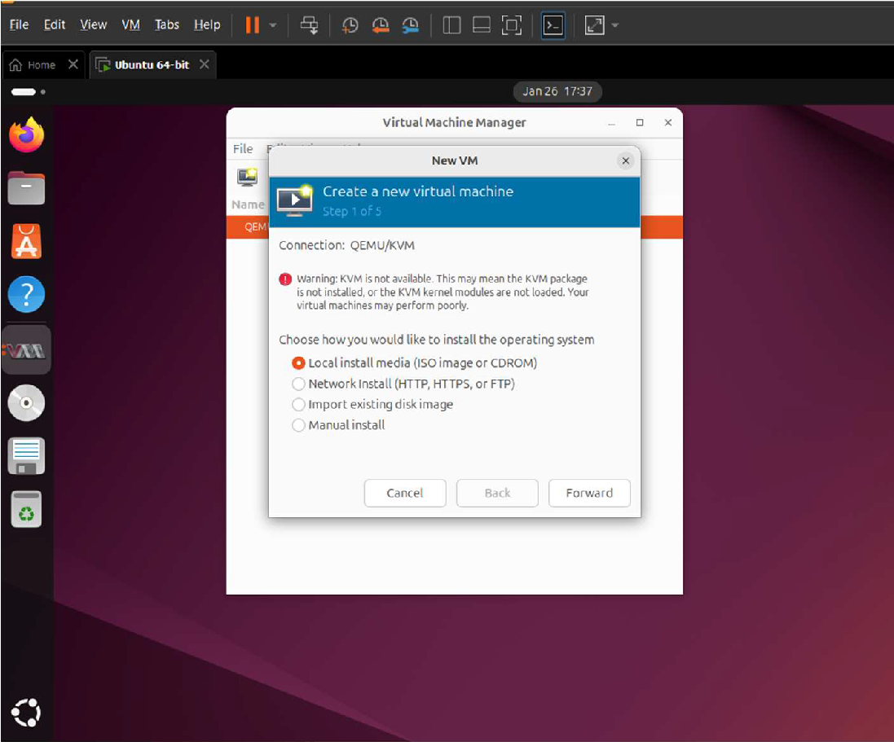

Then ,Select the os to install (eg/:windows, ubuntu etc)

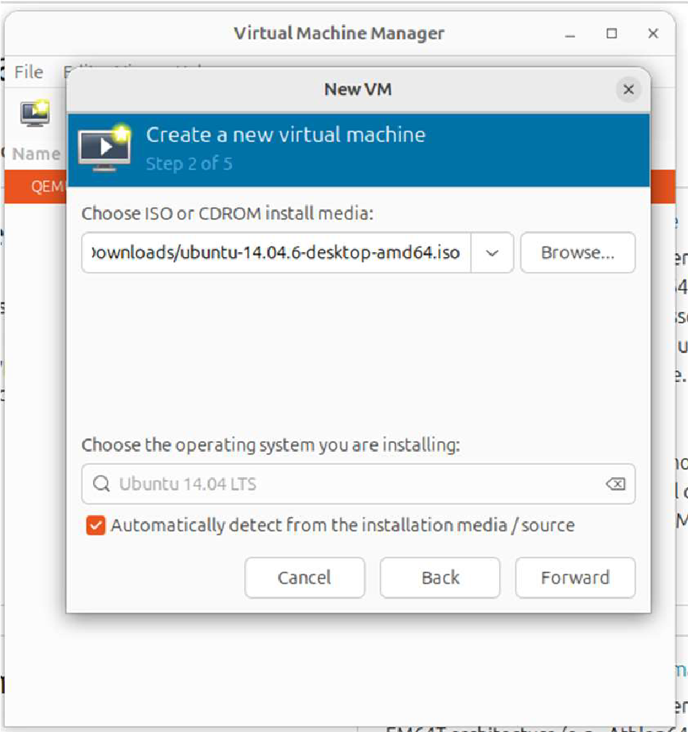

Then

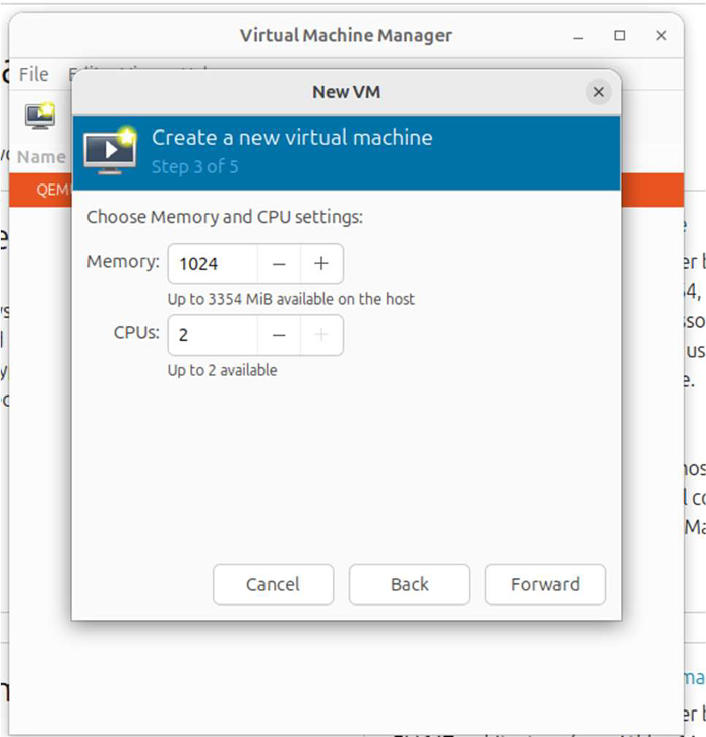

Then

